Affiliations
Member, American Institute of Certified Public Accountants
Member, Virginia Society of Certified Public Accountants
Finance Chairman, Epiphany of Our Lord Byzantine Catholic Church
Former Board Member, Bethesda Chevy Chase Chamber of Commerce
Committee Member, Troop 7369, Boy Scouts of America
Member, Northern Chapter, Virginia Society of Certified Public Accountants

Education and Licenses
Bachelor of Science in Accounting, University of Scranton
Certified Public Accountant – District of Columbia, Maryland and Virginia

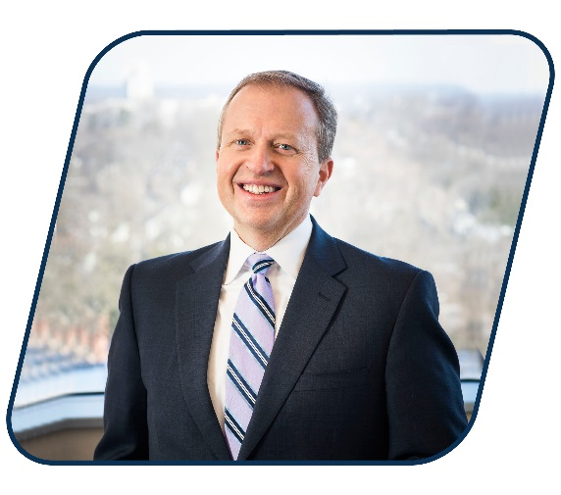

Joel has combined a specialization in professional services with over thirty years of comprehensive public accounting experience, developing a unique set of accounting skills for privately-held businesses. An intuitive and adaptive thinker, Joel has cultivated several areas of expertise since joining the Firm in 1994. His expertise includes reviews and compilations, budget and cash flow projections, audits and internal control design and implementation.
Joel C. Susco, CPA

Principal
susco@bbcpa.com | 301.272.6050

Joel’s comprehensive breadth of knowledge and skill allows him to create custom, cost-sensitive solutions for our clients. In particular, his work with consulting firms, professionals services firms, professional partnerships, small businesses, commercial contractors and wholesale distributors has broadened his keen sense of the issues that affect professional enterprises.

Professional Experience
In addition to his financial services expertise, Mr. Susco possesses a strong knowledge of federal and state tax laws and serves the individual tax needs of many of the Firm’s clients by providing helpful financial insights and developing customized tax strategies. Joel’s tax experience has branched out into estates and trusts for individual clients and family businesses that have been with the firm for many years. Joel is also currently serving as an advisor to several local charitable groups.

